

ATAR Physics

Year 12 2019

**Task 4: Topic Test 2**

**Electromagnetism**

Student Name: _______________________________

Weighting: 10%

I acknowledge that all the information contained in this task is my own work and not taken from other sources. If other sources have been used they have been acknowledged in my references.

____________________________________

(Student Signature)

Teacher Comments:

|  |  |  |  |  |
| --- | --- | --- | --- | --- |
| **Time allowed**: 90 minutes + 5 mins reading time. | | | | |
| **Section** | Number of questions | Your Mark | Marks available | Percentage of Test |
| **Section One:** Short answer | 7 |  | 25 | 28 |
| **Section Two**: Extended answer | 4 |  | 54 | 59 |
| **Section Three:** Comprehension  and data analysis | 1 |  | 12 | 13 |
|  | **Total** |  | **91** | **100** |

Please do not turn the page until instructed to do so

**Section One:** Short answer

**Question 1**

**S N**

⦿

1. The diagram at right shows a permanent magnet and a wire carrying current.
2. Sketch 6 lines to indicate the field of the bar magnet.
3. Indicate on the diagram the direction of magnetic force acting on the wire with an arrow labelled “force”.

**(2 marks)**

1. The diagram at right shows a cross section of a powered solenoid. The magnetic polarity at each end of the solenoid is shown.

**N**

**S**

1. Show on the diagram, the direction of current that will establish this field.
2. Sketch 3 magnetic field lines within the solenoid core.

**(2 marks)**

**Question 2**

A positively charged particle enters a region between two parallel plates set at different voltages. The distance between the plates is 21.0 mm. The electric field strength in the region between the plates is 3.50 × 105 V m-1.

Top Plate = +9350 V

Bottom Plate = ??? V

Charged Particle

21 mm

1. Calculate the voltage of the **bottom plate**.

**(3 marks)**

1. The charged particle experiences a force of magnitude 1.40 ×10-11 N that causes it to deflect towards the bottom plate. Determine the magnitude of charge of the particle.

**(2 marks)**

1. Use five lines with arrowheads to indicate the uniform electric field in the region between the plates.

**(1 mark)**

**Question 3 (2 marks)**

The diagram shows a DC motor with a constant current flowing to the rotor.



Which pair of graphs best describes the behaviour of the force *F* on wire *AB*, and the torque τ on the rotor as functions of time *t*?

 

Question 4

The magnetic flux through a loop of wire is shown. At which lettered point is the emf induced in the loop a maximum?  **(1 mark)**

time

flux Φ

A

B

D

C

ANSWER

**Question 5**

A wire loop, moving right, enters a region where there is a constant, uniform magnetic field pointing into the page. **(2 marks)**

**B**

As the loop enters the B-field, the current induced in the loop is:

1. zero
2. clockwise
3. counter-clockwise

ANSWER

1. out of the page
2. into the page

As the loop enters the B-field, the direction of the net force on the loop is:

1. right →
2. left ←
3. up ↑
4. ↓ down
5. Into the page

ANSWER

1. Out of the page
2. There is no net force

**Question 6**

A student sets up the equipment shown below to conduct an experiment to measure the change in current when a magnet is moved in and out of the wire coil. The student moves the magnet to the left into the coil. Is the induced current through the ammeter to the left or right?.

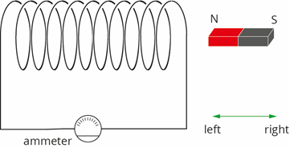

ANSWER

**(1 mark)**

Explain your answer using relevant physics principles. **(3 marks)**

|  |
| --- |
|  |
|  |
|  |
|  |
|  |

**Question 7**

The primary coil of a transformer is connected to a battery, a resistor, and a switch. The secondary coil is connected to an ammeter.

V

iron core

R

A

1. What type of transformer is this? **(1 mark)**
2. When the switch is closed a current spike is read briefly by the ammeter attached to the secondary coil. Which direction will the current flow through the ammeter (up or down)? **(1 mark)**
3. Explain why there is only a brief spike in current initially but the ammeter goes back to reading zero whilst the primary circuit is left closed. **(4 marks)**

|  |
| --- |
|  |
|  |
|  |
|  |
|  |
|  |
|  |

**Section Two** Extended answer

**Question 8**: **The Mass Spectrometer**

1. After initial ionization a mass spectrometer accelerates doubly positive ions towards the velocity selector by using an electric field between two plates. The plates have a potential difference of 500 V. If that mass of one of the ions in the sample is 6.65x10-27 kg, what velocity would you expect it to have just before it reaches the velocity selector? **(3 marks)**
2. The velocity selector consists of a magnetic field which is into the page and an electric field at right angles to it as shown. Draw arrows on the electric field lines to show the direction of field required to allow the positively charged ions to pass through the selector without deviation. **(1 mark)**

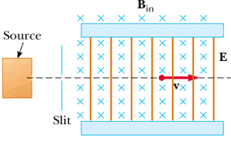

1. Explain / prove that the selected velocity, $v=\frac{E}{B}$ is a constant value for the selector to work using other equations from your data sheet. **(3 marks)**

1. If the velocity selector is to allow the ions from part a) through without deflection, what must be the strength of the magnetic field present in it, given that the selector uses the same voltage as the accelerator across plates separated by a distance of 2.00 cm? If you did not get an answer for a) use the value of 2.27x105 ms-1 as the required velocity. **(3 marks)**
2. 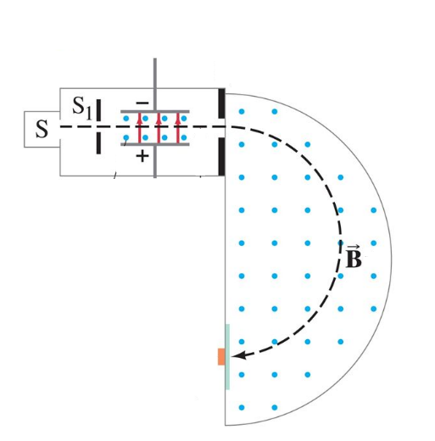A 6.65x10-27 kg particle with a charge of 3.2×10−19 C enters a magnetic field of magnitude 0.14 T with a velocity of 4.0×105 m s−1 that is perpendicular to the magnetic field as shown. Calculate the distance between its entry point and its impact point on the detector. **(3 marks)**
3. Explain why charged particles move with uniform circular motion when they enter a magnetic field with a velocity that is perpendicular to the magnetic field. **(3 marks)**

**Question 9: The Motor Effect**

1. A single rectangular wire loop is connected to a DC power supply. Side X of the loop is placed next to a magnet. The loop is free to rotate about a pivot. When the power is switched on, a current of 20 A is supplied to the loop. To prevent rotation, a mass of 40 g can be attached to either side X or side Y of the loop.

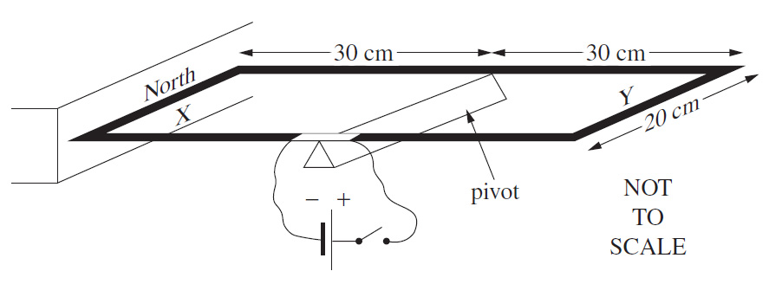

1. Which side would you apply the mass to achieve balance (X or Y)? **(1 mark)**

1. What must the magnetic field strength on side X be to achieve this balance? **(3 marks)**

The diagram below shows an electric motor that produces its magnetic field from field coils either side of the rotor coil. The two coils are in series with the motor and thus get the same current.



1. Draw one arrow labelled **“B”** to show the direction of the magnetic field you would expect to be formed. **(1 mark)**
2. Draw an arrow labelled **“F”** to show the direction of force you would expect to be exerted on side **PQ** at this moment in its rotation. **(1 mark)**

The armature / rotor coil has 150 turns. Side PQ is 5.00 cm and side QR is 4.00cm long. When connected to a 12V DC power supply the current flow is 0.750 A and the field coils produce a magnetic field of 9.50 x 10-2 T.

1. Calculate the total force on the side PQ when it is in this position. **(2 marks)**

1. Calculate the torque on the coil when it is:
2. Horizontal **(2 marks)**
3. 1/6 th of a complete rotation from horizontal. **(3 marks)**

**Question 10**

An engineer was testing a new generator for a wind turbine. The turbine was placed in a wind tunnel and connected to the generator, measuring the voltage produced over time.   
The generator consisted of a circular coil of 5000 turns and radius 50 cm. The graph below shows the results of these measurements.

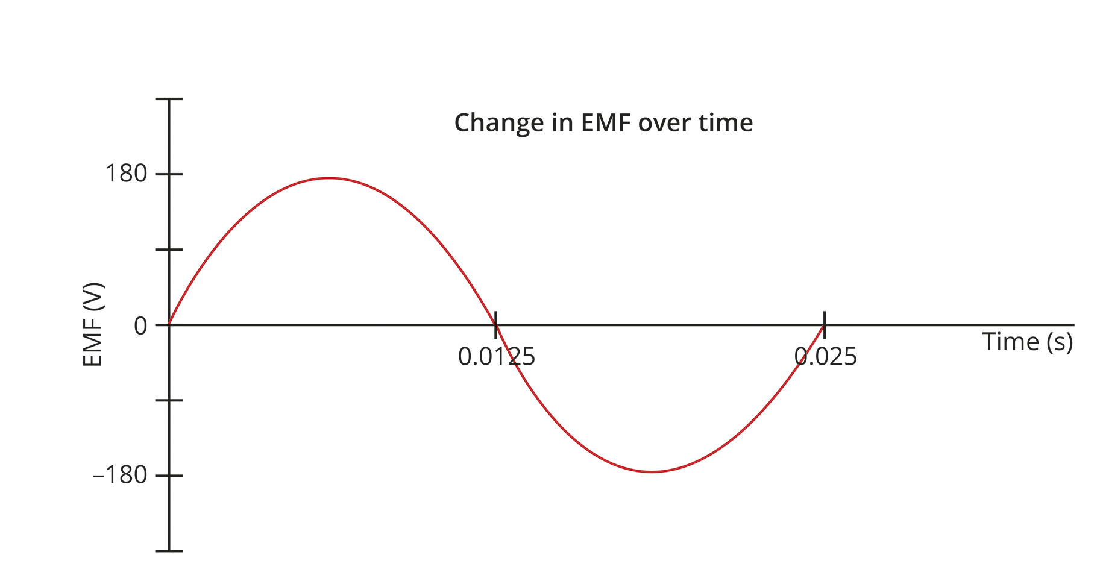

1. Using the data provided and the graph above, determine the strength of the magnetic field used in this generator. **(5 marks)**
2. What is the RMS EMF output produced by the turbine? **(1 mark)**
3. The engineer adjusts the parameters described below to check their effect on induced e.m.f. For each described parameter, sketch the new e.m.f. graph you would expect to observe and clearly explain the reasons for differences observed to the right of each graph. **(7 marks)**

Explanations

* 1. the magnitude of the magnetic field is doubled.

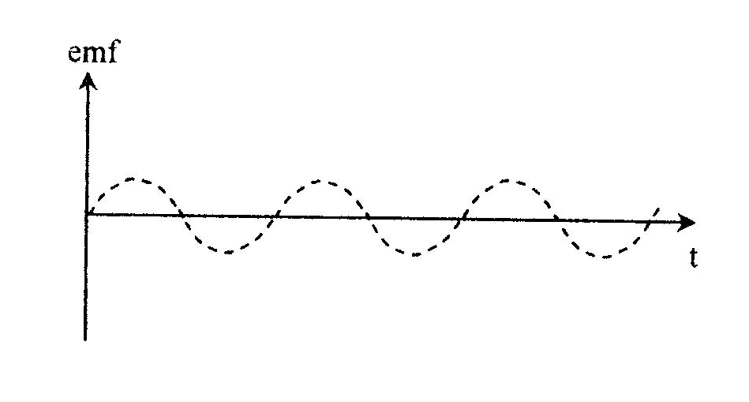E

* 1. the number of turns in the coil is doubled.



* 1. the rate of rotation of the coil is doubled.



**Question 11**

The Kwinana Power Station in Naval Base, Western Australia, has a generating capacity of 420 MW. The power station is located long distances from the homes to which it supplies power at 240V.

The power station does not transmit the power at 240V however, and uses transformers to increase and decrease voltage along the way to the consumers.

The voltage is initially increased from 15.0 kV to 66.0 kV, before being increased again to 132 kV or 330 kV depending on where it is being supplied.

1. Quantitatively describe how the number of coils in each part of the first transformer compare. **(2 marks)**

1. The transformers have laminated iron cores. Briefly explain the purpose of laminating the iron in the cores. **(2 marks)**

|  |
| --- |
|  |
|  |
|  |

1. The Table below provides some data about two of the transformers used in the Kwinana power distribution system complete the missing values. **(2 marks)**

|  |  |  |  |  |  |
| --- | --- | --- | --- | --- | --- |
| **PRIMARY** | | | **SECONDARY** | | |
| Np | Vp (volts) | Ip (amps) | Ns | Vs (volts) | Is (amps) |
| 2550 | 66 000 | 1000 |  | 132000 |  |
| 6250 |  | 3.024 |  | 240 | 63 |

1. One farm house on the distribution network has a transformer outside the main building has an output of 240 Volts. The farmer has just built a work shed 230m from transformer and wants to know if he can run an underground electrical cable to the barn so he can operate a small grain mill there to test the quality of his crop.

The mill requires a minimum of 200V to operate properly and the farmer is using cables with resistances of 13.2 x 10-3 Ω m-1. The mill will draw 12.0 A of current through the cable when operating.

Will the machine operate properly? Show calculations to support your answer. **(6 marks)**

**Section Three:** Comprehension and data analysis

**Question 12: Interpreting Data**

Some university students are investigating the circular magnetic field formed around a long straight wire carrying electrical current. They use a probe that measures magnetic flux density at different radii of separation from the wire.

*Separation between meter and wire*

*Probe that measures magnetic flux density*

⦿

*Current carrying wire*

The students know that the magnetic flux density decreases with increasing distance from the wire.

The students put a 90 cm straight length of wire between two clamps such that no objects (other than the probe) are closer than 40 cm to the centre of the wire.

A steady current of 2200 A is fed into the wire from an external power supply.

The probe that measures magnetic flux density is placed at set distances from the middle of the wire and measurements recorded.

The students analyse the difficulty obtaining a precise measurement of magnetic flux density and decide to record this data with an uncertainty of ±7%.

The magnetic flux density B, due to a current I, passing in a wire is given by the expression:

$$B= \frac{μ_{0}I}{2πr}$$

Where, $μ_{0}$ = the permeability of free space (H m-1), which is a measure of the extent to which the surrounding medium reinforces the magnetic field.

r = radius of separation (m)

The results obtained are as follows:

|  |  |  |
| --- | --- | --- |
| **Radius of separation**  **(m)** | **(m-1)** | **Magnetic Flux Density**  **(x 10-3 T)** |
| 0.065 | 15.4 | 6.70 ± 0.47 |
| 0.080 |  | 5.90 |
| 0.100 |  | 4.50 |
| 0.125 |  | 3.50 |
| 0.200 |  | 2.10 |
| 0.500 |  | 0.90 ± 0.06 |

**Answer the following questions:**

1. Complete the second column of the table $\frac{1}{r}$, so that you can plot a straight line graph.

One value has been done for you. **(1 mark)**

1. Complete the third column of the table **(Magnetic Flux Density)** to include the uncertainty for each measurement. Two values have been done for you. **(1 mark)**
2. Plot a graph of Magnetic Flux Density (B) on the vertical axis versus $\frac{1}{r}$ on the horizontal axis.

**(4 marks)**

C:\Documents and Settings\Peter\My Documents\Physics\PG Documents\Year 11 Physics\7. Y11 Exams\2009 S2\Sec C 8 by 7 line weight 25 and 4.emf

1. Calculate the gradient of your graph showing all working. **(3 marks)**

1. Determine the value of $μ_{0}$, the permeability of free space, from the value of the gradient that you obtained. (If you could not determine the gradient use the numerical value 4.40 x 10-4). **(3 marks)**

**End of Test**